

**Mawlana Bhashani Science and Technology University**

Santosh, Tangail-1902.

|  |
| --- |
| **Lab Report** |

Department of Information and Communication Technology

**Report No:** 03

**Report Name:** TCP and router queues.

**Course Title:** Wireless and Mobile Communication.

**Course Code:** ICT-4201

|  |  |
| --- | --- |
| Submitted By | Submitted To |
| Name: **Mohammad Mehedy Hasan Ridoy**  ID: **IT-16024**  Session: 2015-16  4th Year 2nd Semester  Dept. of Information & Communication Technology, MBSTU. | Nazrul Islam  Assistant Professor  Dept. of Information & Communication Technology, MBSTU. |

Submission Date: 11-09-2020

**Experiment N0: 03**

**Name of Experiments: TCP and Router Queues.**

**Objectives**:

1. Create a simple dumbbell topology, two client Node1 and Node2 on the left side of the dumbbell and server nodes Node3 and Node4 on the right side of the dumbbell. Let Node5 and Node6 form the bridge of the dumbbell. Use point to point links.
2. Install a TCP socket instance on Node1 that will connect to Node3.
3. Install a UDP socket instance on Node2 that will connect to Node4.
4. Start the TCP application at time 1s.
5. Start the UDP application at time 20s at rate Rate1 such that it clogs half the dumbbell bridge's link capacity.
6. Increase the UDP application's rate at time 30s to rate Rate2 such that it clogs the whole of the dumbbell bridge's capacity.
7. Use the ns-3 tracing mechanism to record changes in congestion window size of the TCP instance over time. Use gnuplot/matplotlib to visualize plots of cwnd vs time.
8. Mark points of fast recovery and slow start in the graphs.
9. Perform the above experiment for TCP variants Tahoe, Reno and New Reno, all of which are available with ns-3.

**Source Code**:

/* -*- Mode:C++; c-file-style:"gnu"; indent-tabs-mode:nil; -*- */

/*

* Copyright (c) 2015 Universita' degli Studi di Napoli Federico II

*

* This program is free software; you can redistribute it and/or modify

* it under the terms of the GNU General Public License version 2 as

* published by the Free Software Foundation;

*

* This program is distributed in the hope that it will be useful,

* but WITHOUT ANY WARRANTY; without even the implied warranty of

* MERCHANTABILITY or FITNESS FOR A PARTICULAR PURPOSE. See the

* GNU General Public License for more details.

*

* You should have received a copy of the GNU General Public License

* along with this program; if not, write to the Free Software

* Foundation, Inc., 59 Temple Place, Suite 330, Boston, MA 02111-1307 USA

*

* Authors: Pasquale Imputato <p.imputato@gmail.com>

* Stefano Avallone <stefano.avallone@unina.it>

*/

// This example serves as a benchmark for all the queue discs (with BQL enabled or not)

//

// Network topology

//

// 192.168.1.0 192.168.2.0

// n1 ------------------------------------ n2 ----------------------------------- n3

// point-to-point (access link) point-to-point (bottleneck link)

// 100 Mbps, 0.1 ms bandwidth [10 Mbps], delay [5 ms]

// qdiscs PfifoFast with capacity qdiscs queueDiscType in {PfifoFast, ARED, CoDel, FqCoDel, PIE} [PfifoFast]

// of 1000 packets with capacity of queueDiscSize packets [1000]

// netdevices queues with size of 100 packets netdevices queues with size of netdevicesQueueSize packets [100]

// without BQL bql BQL [false]

// *** fixed configuration ***

//

// Two TCP flows are generated: one from n1 to n3 and the other from n3 to n1.

// Additionally, n1 pings n3, so that the RTT can be measured.

//

// The output will consist of a number of ping Rtt such as:

//

// /NodeList/0/ApplicationList/2/$ns3::V4Ping/Rtt=111 ms

// /NodeList/0/ApplicationList/2/$ns3::V4Ping/Rtt=111 ms

// /NodeList/0/ApplicationList/2/$ns3::V4Ping/Rtt=110 ms

// /NodeList/0/ApplicationList/2/$ns3::V4Ping/Rtt=111 ms

// /NodeList/0/ApplicationList/2/$ns3::V4Ping/Rtt=111 ms

// /NodeList/0/ApplicationList/2/$ns3::V4Ping/Rtt=112 ms

// /NodeList/0/ApplicationList/2/$ns3::V4Ping/Rtt=111 ms

#include "ns3/core-module.h"

#include "ns3/network-module.h"

#include "ns3/internet-module.h"

#include "ns3/point-to-point-module.h"

#include "ns3/applications-module.h"

#include "ns3/internet-apps-module.h"

#include "ns3/traffic-control-module.h"

#include "ns3/flow-monitor-module.h"

using namespace ns3;

NS_LOG_COMPONENT_DEFINE ("BenchmarkQueueDiscs");

void

LimitsTrace (Ptr<OutputStreamWrapper> stream, uint32_t oldVal, uint32_t newVal)

{

*stream->GetStream () << Simulator::Now ().GetSeconds () << " " << newVal << std::endl;

}

void

BytesInQueueTrace (Ptr<OutputStreamWrapper> stream, uint32_t oldVal, uint32_t newVal)

{

*stream->GetStream () << Simulator::Now ().GetSeconds () << " " << newVal << std::endl;

}

static void

GoodputSampling (std::string fileName, ApplicationContainer app, Ptr<OutputStreamWrapper> stream, float period)

{

Simulator::Schedule (Seconds (period), &GoodputSampling, fileName, app, stream, period);

double goodput;

uint64_t totalPackets = DynamicCast<PacketSink> (app.Get (0))->GetTotalRx ();

goodput = totalPackets * 8 / (Simulator::Now ().GetSeconds () * 1024); // Kbit/s

*stream->GetStream () << Simulator::Now ().GetSeconds () << " " << goodput << std::endl;

}

static void PingRtt (std::string context, Time rtt)

{

std::cout << context << "=" << rtt.GetMilliSeconds () << " ms" << std::endl;

}

int main (int argc, char *argv[])

{

std::string bandwidth = "10Mbps";

std::string delay = "5ms";

std::string queueDiscType = "PfifoFast";

uint32_t queueDiscSize = 1000;

uint32_t netdevicesQueueSize = 50;

bool bql = false;

std::string flowsDatarate = "20Mbps";

uint32_t flowsPacketsSize = 1000;

float startTime = 0.1f; // in s

float simDuration = 60;

float samplingPeriod = 1;

CommandLine cmd (__FILE__);

cmd.AddValue ("bandwidth", "Bottleneck bandwidth", bandwidth);

cmd.AddValue ("delay", "Bottleneck delay", delay);

cmd.AddValue ("queueDiscType", "Bottleneck queue disc type in {PfifoFast, ARED, CoDel, FqCoDel, PIE, prio}", queueDiscType);

cmd.AddValue ("queueDiscSize", "Bottleneck queue disc size in packets", queueDiscSize);

cmd.AddValue ("netdevicesQueueSize", "Bottleneck netdevices queue size in packets", netdevicesQueueSize);

cmd.AddValue ("bql", "Enable byte queue limits on bottleneck netdevices", bql);

cmd.AddValue ("flowsDatarate", "Upload and download flows datarate", flowsDatarate);

cmd.AddValue ("flowsPacketsSize", "Upload and download flows packets sizes", flowsPacketsSize);

cmd.AddValue ("startTime", "Simulation start time", startTime);

cmd.AddValue ("simDuration", "Simulation duration in seconds", simDuration);

cmd.AddValue ("samplingPeriod", "Goodput sampling period in seconds", samplingPeriod);

cmd.Parse (argc, argv);

float stopTime = startTime + simDuration;

// Create nodes

NodeContainer n1, n2, n3;

n1.Create (1);

n2.Create (1);

n3.Create (1);

// Create and configure access link and bottleneck link

PointToPointHelper accessLink;

accessLink.SetDeviceAttribute ("DataRate", StringValue ("100Mbps"));

accessLink.SetChannelAttribute ("Delay", StringValue ("0.1ms"));

accessLink.SetQueue ("ns3::DropTailQueue", "MaxSize", StringValue ("100p"));

PointToPointHelper bottleneckLink;

bottleneckLink.SetDeviceAttribute ("DataRate", StringValue (bandwidth));

bottleneckLink.SetChannelAttribute ("Delay", StringValue (delay));

bottleneckLink.SetQueue ("ns3::DropTailQueue", "MaxSize", StringValue (std::to_string (netdevicesQueueSize) + "p"));

InternetStackHelper stack;

stack.InstallAll ();

// Access link traffic control configuration

TrafficControlHelper tchPfifoFastAccess;

tchPfifoFastAccess.SetRootQueueDisc ("ns3::PfifoFastQueueDisc", "MaxSize", StringValue ("1000p"));

// Bottleneck link traffic control configuration

TrafficControlHelper tchBottleneck;

if (queueDiscType.compare ("PfifoFast") == 0)

{

tchBottleneck.SetRootQueueDisc ("ns3::PfifoFastQueueDisc", "MaxSize",

QueueSizeValue (QueueSize (QueueSizeUnit::PACKETS, queueDiscSize)));

}

else if (queueDiscType.compare ("ARED") == 0)

{

tchBottleneck.SetRootQueueDisc ("ns3::RedQueueDisc");

Config::SetDefault ("ns3::RedQueueDisc::ARED", BooleanValue (true));

Config::SetDefault ("ns3::RedQueueDisc::MaxSize",

QueueSizeValue (QueueSize (QueueSizeUnit::PACKETS, queueDiscSize)));

}

else if (queueDiscType.compare ("CoDel") == 0)

{

tchBottleneck.SetRootQueueDisc ("ns3::CoDelQueueDisc");

Config::SetDefault ("ns3::CoDelQueueDisc::MaxSize",

QueueSizeValue (QueueSize (QueueSizeUnit::PACKETS, queueDiscSize)));

}

else if (queueDiscType.compare ("FqCoDel") == 0)

{

tchBottleneck.SetRootQueueDisc ("ns3::FqCoDelQueueDisc");

Config::SetDefault ("ns3::FqCoDelQueueDisc::MaxSize",

QueueSizeValue (QueueSize (QueueSizeUnit::PACKETS, queueDiscSize)));

}

else if (queueDiscType.compare ("PIE") == 0)

{

tchBottleneck.SetRootQueueDisc ("ns3::PieQueueDisc");

Config::SetDefault ("ns3::PieQueueDisc::MaxSize",

QueueSizeValue (QueueSize (QueueSizeUnit::PACKETS, queueDiscSize)));

}

else if (queueDiscType.compare ("prio") == 0)

{

uint16_t handle = tchBottleneck.SetRootQueueDisc ("ns3::PrioQueueDisc", "Priomap",

StringValue ("0 1 0 1 0 1 0 1 0 1 0 1 0 1 0 1"));

TrafficControlHelper::ClassIdList cid = tchBottleneck.AddQueueDiscClasses (handle, 2, "ns3::QueueDiscClass");

tchBottleneck.AddChildQueueDisc (handle, cid[0], "ns3::FifoQueueDisc");

tchBottleneck.AddChildQueueDisc (handle, cid[1], "ns3::RedQueueDisc");

}

else

{

NS_ABORT_MSG ("--queueDiscType not valid");

}

if (bql)

{

tchBottleneck.SetQueueLimits ("ns3::DynamicQueueLimits");

}

NetDeviceContainer devicesAccessLink = accessLink.Install (n1.Get (0), n2.Get (0));

tchPfifoFastAccess.Install (devicesAccessLink);

Ipv4AddressHelper address;

address.SetBase ("192.168.0.0", "255.255.255.0");

address.NewNetwork ();

Ipv4InterfaceContainer interfacesAccess = address.Assign (devicesAccessLink);

NetDeviceContainer devicesBottleneckLink = bottleneckLink.Install (n2.Get (0), n3.Get (0));

QueueDiscContainer qdiscs;

qdiscs = tchBottleneck.Install (devicesBottleneckLink);

address.NewNetwork ();

Ipv4InterfaceContainer interfacesBottleneck = address.Assign (devicesBottleneckLink);

Ptr<NetDeviceQueueInterface> interface = devicesBottleneckLink.Get (0)->GetObject<NetDeviceQueueInterface> ();

Ptr<NetDeviceQueue> queueInterface = interface->GetTxQueue (0);

Ptr<DynamicQueueLimits> queueLimits = StaticCast<DynamicQueueLimits> (queueInterface->GetQueueLimits ());

AsciiTraceHelper ascii;

if (bql)

{

queueDiscType = queueDiscType + "-bql";

Ptr<OutputStreamWrapper> streamLimits = ascii.CreateFileStream (queueDiscType + "-limits.txt");

queueLimits->TraceConnectWithoutContext ("Limit",MakeBoundCallback (&LimitsTrace, streamLimits));

}

Ptr<Queue<Packet> > queue = StaticCast<PointToPointNetDevice> (devicesBottleneckLink.Get (0))->GetQueue ();

Ptr<OutputStreamWrapper> streamBytesInQueue = ascii.CreateFileStream (queueDiscType + "-bytesInQueue.txt");

queue->TraceConnectWithoutContext ("BytesInQueue",MakeBoundCallback (&BytesInQueueTrace, streamBytesInQueue));

Ipv4InterfaceContainer n1Interface;

n1Interface.Add (interfacesAccess.Get (0));

Ipv4InterfaceContainer n3Interface;

n3Interface.Add (interfacesBottleneck.Get (1));

Ipv4GlobalRoutingHelper::PopulateRoutingTables ();

Config::SetDefault ("ns3::TcpSocket::SegmentSize", UintegerValue (flowsPacketsSize));

// Flows configuration

// Bidirectional TCP streams with ping like flent tcp_bidirectional test.

uint16_t port = 7;

ApplicationContainer uploadApp, downloadApp, sourceApps;

// Configure and install upload flow

Address addUp (InetSocketAddress (Ipv4Address::GetAny (), port));

PacketSinkHelper sinkHelperUp ("ns3::TcpSocketFactory", addUp);

sinkHelperUp.SetAttribute ("Protocol", TypeIdValue (TcpSocketFactory::GetTypeId ()));

uploadApp.Add (sinkHelperUp.Install (n3));

InetSocketAddress socketAddressUp = InetSocketAddress (n3Interface.GetAddress (0), port);

OnOffHelper onOffHelperUp ("ns3::TcpSocketFactory", Address ());

onOffHelperUp.SetAttribute ("Remote", AddressValue (socketAddressUp));

onOffHelperUp.SetAttribute ("OnTime", StringValue ("ns3::ConstantRandomVariable[Constant=1]"));

onOffHelperUp.SetAttribute ("OffTime", StringValue ("ns3::ConstantRandomVariable[Constant=0]"));

onOffHelperUp.SetAttribute ("PacketSize", UintegerValue (flowsPacketsSize));

onOffHelperUp.SetAttribute ("DataRate", StringValue (flowsDatarate));

sourceApps.Add (onOffHelperUp.Install (n1));

port = 8;

// Configure and install download flow

Address addDown (InetSocketAddress (Ipv4Address::GetAny (), port));

PacketSinkHelper sinkHelperDown ("ns3::TcpSocketFactory", addDown);

sinkHelperDown.SetAttribute ("Protocol", TypeIdValue (TcpSocketFactory::GetTypeId ()));

downloadApp.Add (sinkHelperDown.Install (n1));

InetSocketAddress socketAddressDown = InetSocketAddress (n1Interface.GetAddress (0), port);

OnOffHelper onOffHelperDown ("ns3::TcpSocketFactory", Address ());

onOffHelperDown.SetAttribute ("Remote", AddressValue (socketAddressDown));

onOffHelperDown.SetAttribute ("OnTime", StringValue ("ns3::ConstantRandomVariable[Constant=1]"));

onOffHelperDown.SetAttribute ("OffTime", StringValue ("ns3::ConstantRandomVariable[Constant=0]"));

onOffHelperDown.SetAttribute ("PacketSize", UintegerValue (flowsPacketsSize));

onOffHelperDown.SetAttribute ("DataRate", StringValue (flowsDatarate));

sourceApps.Add (onOffHelperDown.Install (n3));

// Configure and install ping

V4PingHelper ping = V4PingHelper (n3Interface.GetAddress (0));

ping.Install (n1);

Config::Connect ("/NodeList/*/ApplicationList/*/$ns3::V4Ping/Rtt", MakeCallback (&PingRtt));

uploadApp.Start (Seconds (0));

uploadApp.Stop (Seconds (stopTime));

downloadApp.Start (Seconds (0));

downloadApp.Stop (Seconds (stopTime));

sourceApps.Start (Seconds (0 + 0.1));

sourceApps.Stop (Seconds (stopTime - 0.1));

Ptr<OutputStreamWrapper> uploadGoodputStream = ascii.CreateFileStream (queueDiscType + "-upGoodput.txt");

Simulator::Schedule (Seconds (samplingPeriod), &GoodputSampling, queueDiscType + "-upGoodput.txt", uploadApp,

uploadGoodputStream, samplingPeriod);

Ptr<OutputStreamWrapper> downloadGoodputStream = ascii.CreateFileStream (queueDiscType + "-downGoodput.txt");

Simulator::Schedule (Seconds (samplingPeriod), &GoodputSampling, queueDiscType + "-downGoodput.txt", downloadApp,

downloadGoodputStream, samplingPeriod);

// Flow monitor

Ptr<FlowMonitor> flowMonitor;

FlowMonitorHelper flowHelper;

flowMonitor = flowHelper.InstallAll();

Simulator::Stop (Seconds (stopTime));

Simulator::Run ();

flowMonitor->SerializeToXmlFile(queueDiscType + "-flowMonitor.xml", true, true);

Simulator::Destroy ();

return 0

}

**Output:**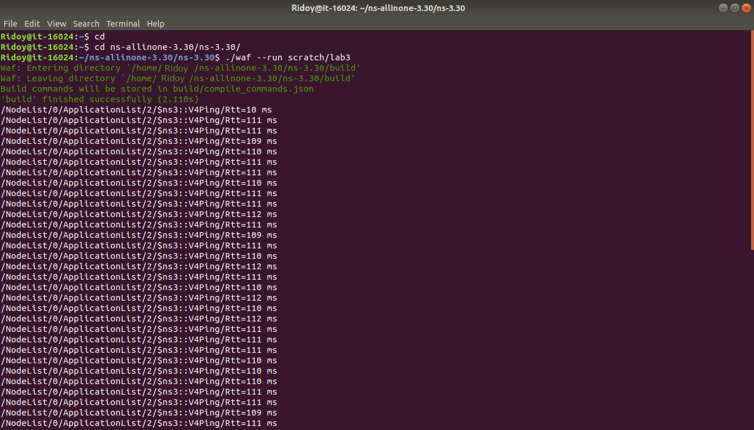

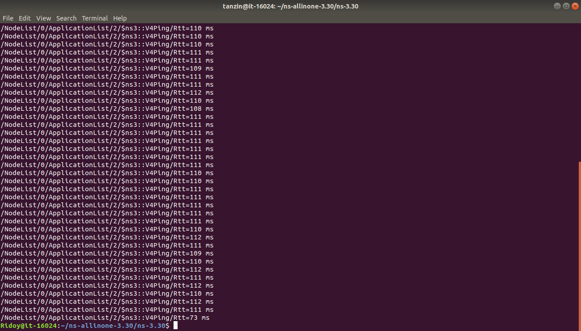

**Conclusion:**

The files output will consist of a trace file with bytes in queue and of a trace file for limit (when BQL is enabled) both for bottleneck NetDevice on n2, two files with upload and download goodput for flows configuration and a file with flow monitor stats. If we use an AQM as queue disc on the bottleneck netdevices, it will be observed that the ping Rtt decrease. A further decrease can be observed by enabling BQL.